Third Grade Book Report
Due November 30, 2017
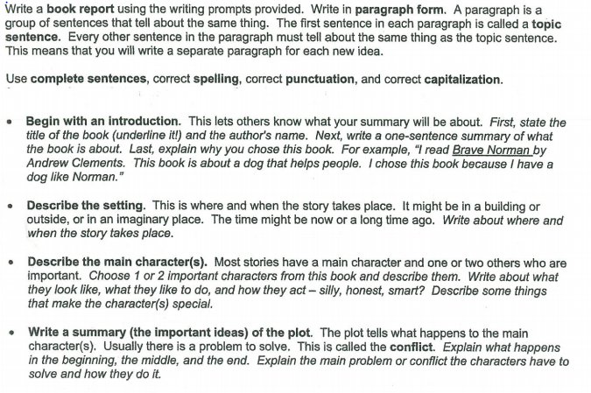

Make sure that you rewrite and complete the sentence frames on a piece of notebook paper. You may use this sheet to help you with your first draft. All reports should be rewritten on another piece of paper to be turned in. This sheet will not be accepted. The students will work on the picture/artwork for their report in class. All reports are due on or before November 30th.

