### May Howard

### Elementary School

### April 2, 2018

Volume 1, Issue 14

Mrs. Phillips’

Class

banner with apples and crayons

April 5 Bus Evacuation Drill

April 10 PTA Reflections Ceremony 5:30

April 11-17 GMAS

April 26th Oatland Island Field Trip

April 27th Field Day



**April**

**2nd Olivia**

**10th Charlie**

**20th Grady**

## Important Dates

Math

Geometry

Reading

Comparing and Contrasting stories

Language Arts

Adjectives

Science

Georgia Habitats

Social Studies

Colonies

## Specials this week…

**Monday- STEM**

**Tuesday- Music**

**Wednesday- No Specials**

**Thursday- Spanish**

**Friday- PE**

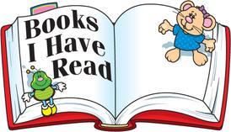

## Reminders to Parents

Please send in books for our Million Book Challenge.

#### Thank You!

This week we are focusing on comparing and contrasting stories in reading. During our writing block, the students are working on writing informational and opinion pieces.

Math is all about GEOMETRY!

This week we will have a vocabulary test. We have be practicing these words in class. The spelling test will be given next Tuesday. Students also have access to Spelling City to practice spelling words.

Check out our class website at

<http://phillipshawks.weebly.com>

Classroom Newsletter

A Special thanks to all parents for sharing your child with me.

# Curriculum Corner

# A Note from the Teacher