### May Howard

### Elementary School

### October 16, 2017

Volume 1, Issue 6

Mrs. Phillips’

Class

banner with apples and crayons

**Monday- STEM**

**Tuesday- Music**

**Wednesday- Super Specials**

**Thursday- Spanish**

**Friday- Technology**

## Specials this week…

Math

Elapsed Time/Measurement

Reading

Stories/Dramas/Plays

Language Arts

Nouns

Science

Rocks and Minerals

Social Studies

American Indians

#### Thank You!

Please send in books for our Million Book Challenge.

Boosterthon Fun Run is this THURSDAY at 8:15

## Reminders to Parents

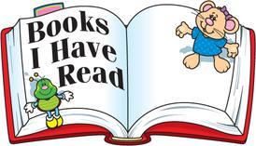

The mystery book reports were amazing. Please give me feedback on how your child did with this at home. I would like to assign a book reports throughout the year.

The students will be creating catapults for a “Pumpkin Chunkin” contest. Please send in supplies that I sent in my previous email.

The Boosterthon Fun Run is this Thursday. Please plan on joining us in the fun. Third grade will be running from 8:15-9:15.

Check out our class website at

<http://phillipshawks.weebly.com>

Oct. 19 Boosterthon Fun Run 8:15

Oct. 23 Report Cards Issued



**October**

9th * Emmet

25th * Emma

## Important Dates

Classroom Newsletter

A Special thanks to all parents for sharing your child with me.

# Curriculum Corner

# A Note from the Teacher