### May Howard

### Elementary School

### January 9, 2018

Volume 1, Issue 9

Mrs. Phillips’

Class

banner with apples and crayons

**Monday- PE**

**Tuesday- Art**

**Wednesday- STEM**

**Thursday- Music**

**Friday- Spanish**

## Specials this week…

Math

Multiplication/Division and Area

Reading

Cause and Effect/ unknown words

Language Arts

Abstract Nouns

Science

Heat Energy

Social Studies

European Explorer- Vasco

#### Thank You!

Please send in books for our Million Book Challenge.

## Reminders to Parents

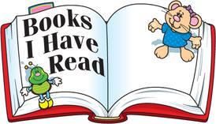

Welcome back! I hope everyone had a wonderful extended winter break. We are now in the second semester and I am so excited in the growth of all of the kids.

This semester is very important and busy. January is a big benchmark month. Our class will be taking the MAP reading and math assessments this month. This is an excited time because we will see how much growth each child has made. Please make sure that your child is at school every day.

Check out our class website at

<http://phillipshawks.weebly.com>

January 16-17 MAP Reading Test

January 22-23 MAP Math Test

January 26 Student Dress Down $1.00

January 30 Class Group Picture



**January**

**9th Max**

**18th Liberty**

**30th Dean**

## Important Dates

Classroom Newsletter

A Special thanks to all parents for sharing your child with me.

# Curriculum Corner

# A Note from the Teacher